Advance JavaScript assignment

Q-1 Write a program to Show an alert?

A-1

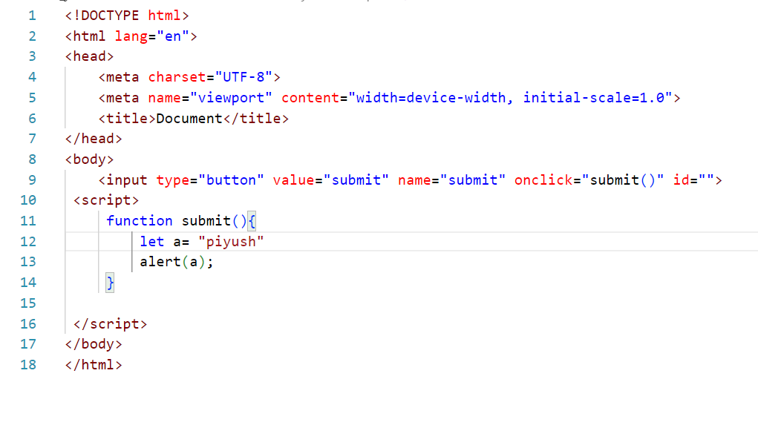

Q.2 What will be the result for these expressions?

(1) 5 > 4

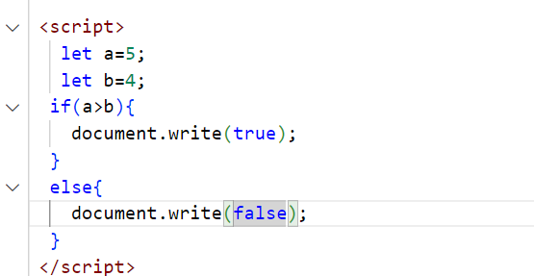

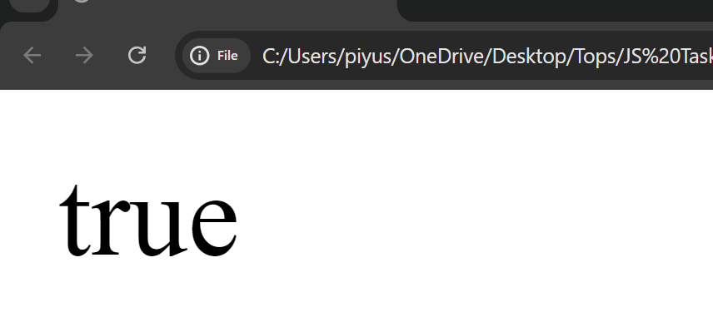

(2) . "apple" > "pineapple"

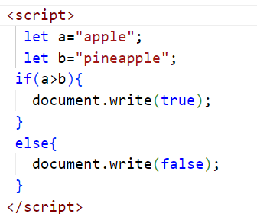

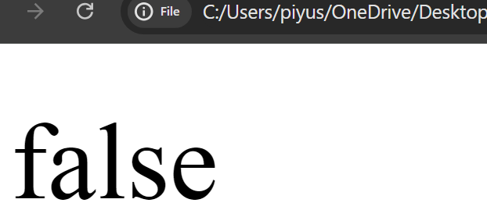

(3)“2" > "12"

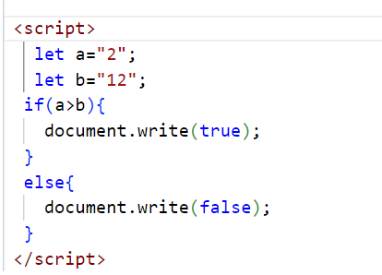

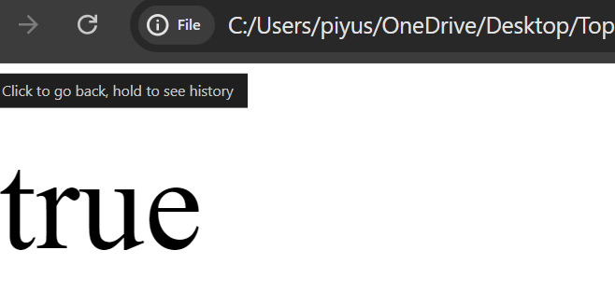

(4) undefined == null

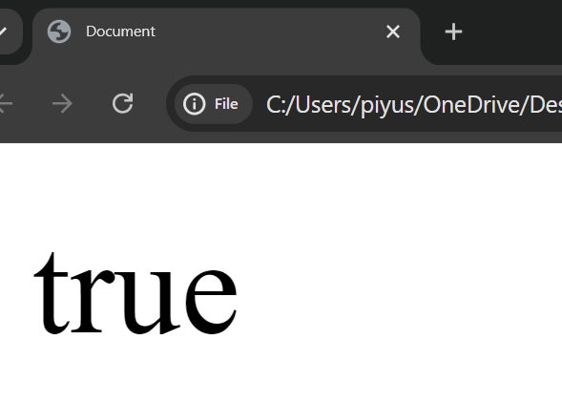

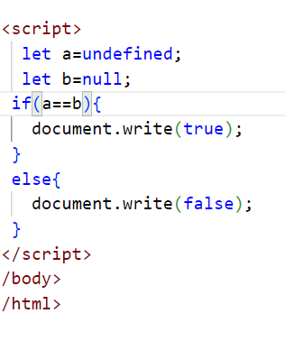

(5)undefined === null

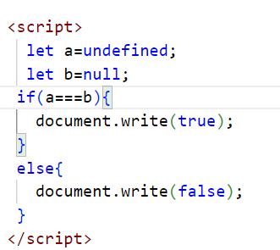

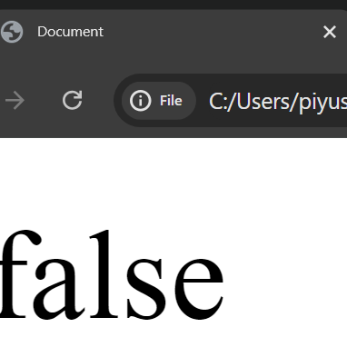

(6) null == "\n0\n"

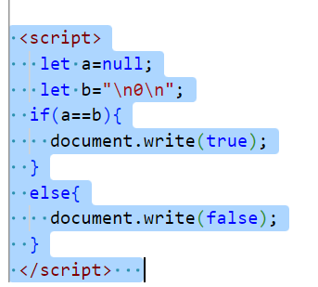

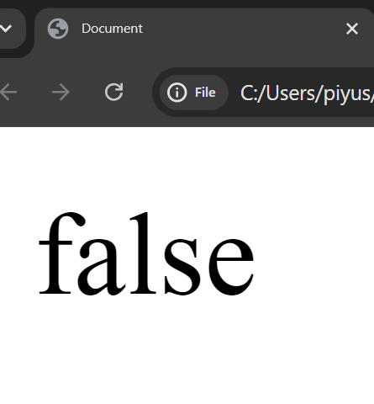

(7) null === +"\n0\n"

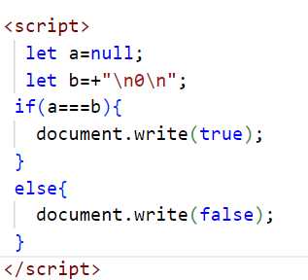

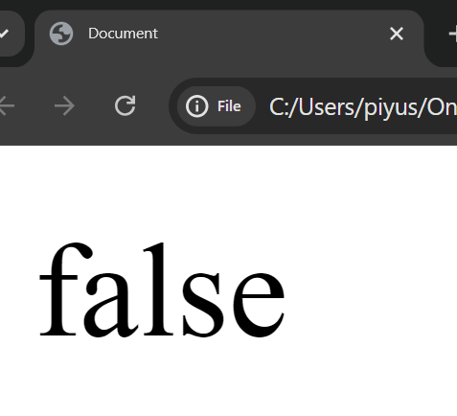

Q-3 Will alert be shown? 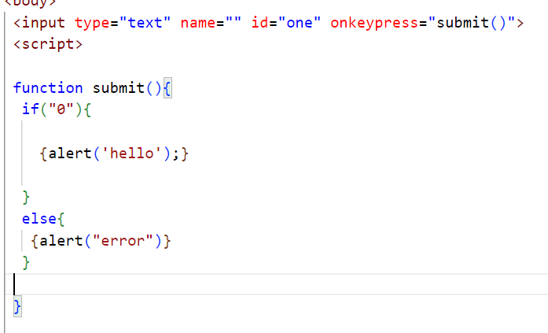

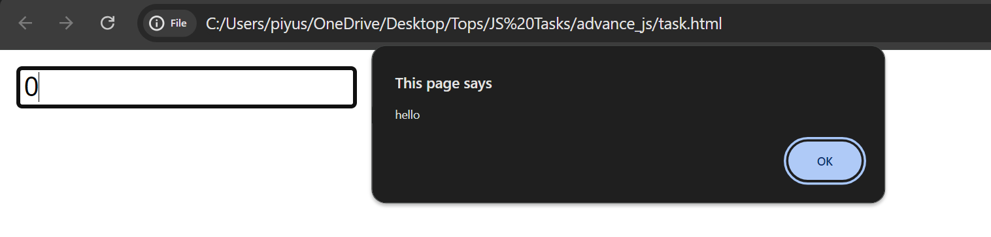

Q-4 What is the code below going to output?

alert (null || 2 || undefined);

A-4

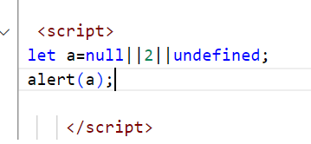

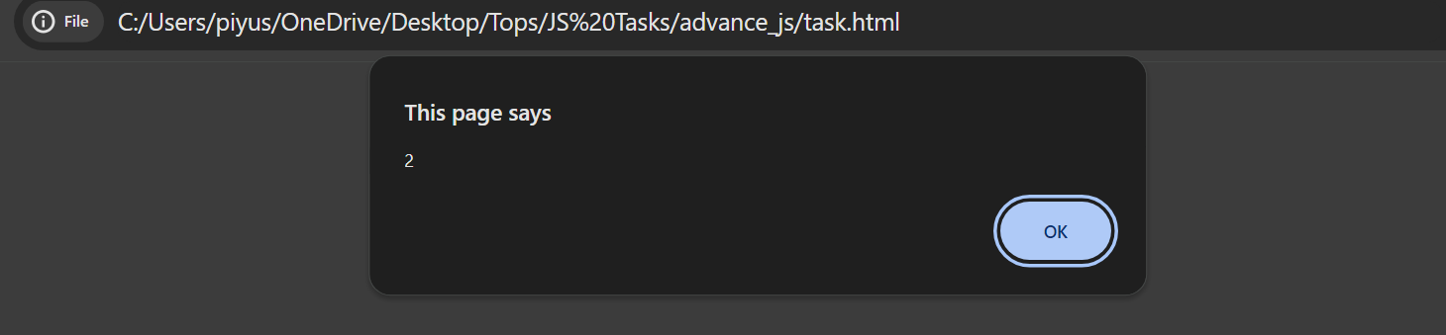

Q-5-The following function returns true if the parameter age is greater than 18. xOtherwise, it asks for a confirmation and returns its result:

Ans-5

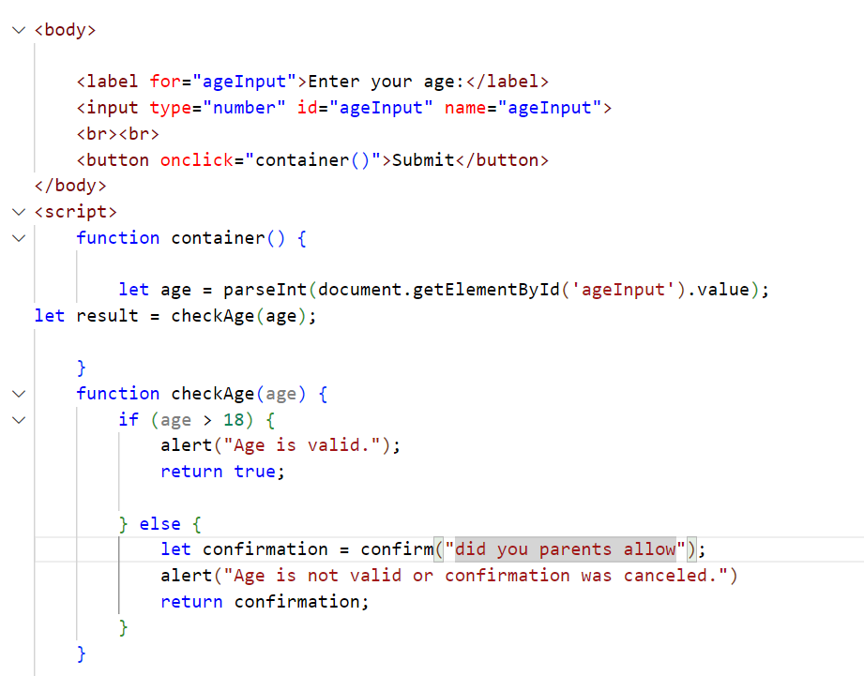

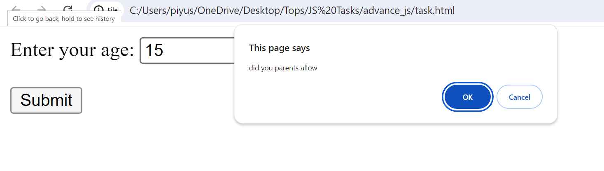

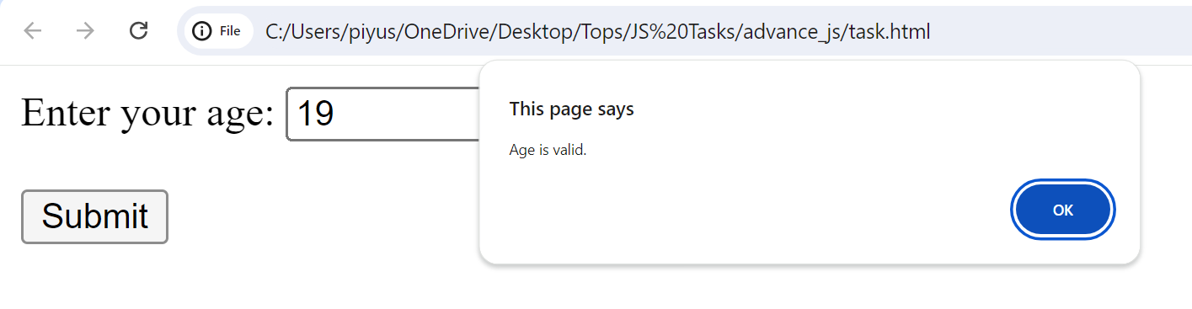

Q-6 Replace Function Expressions with arrow functions in the code below

Ans-6

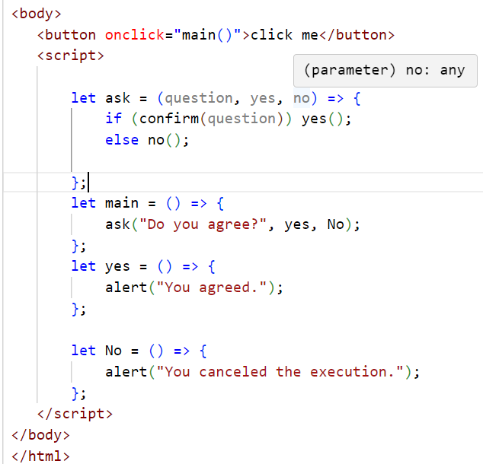

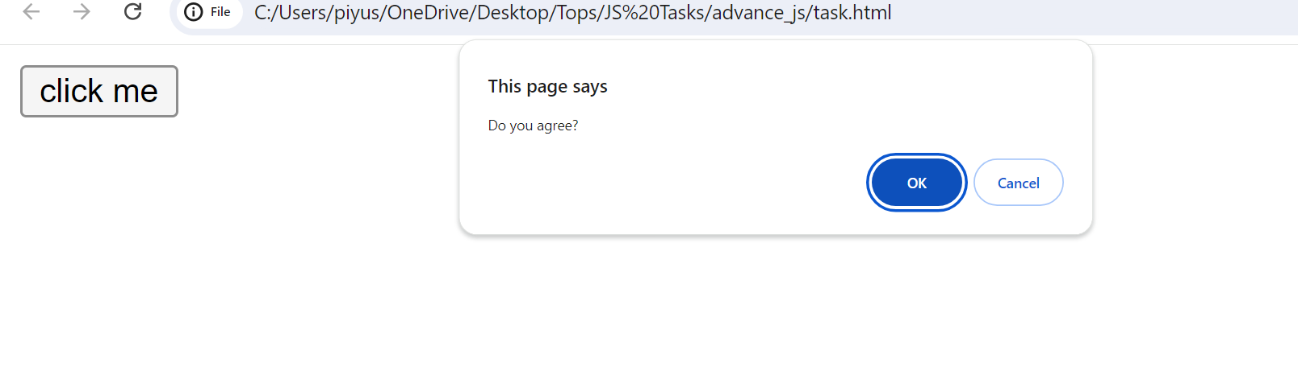

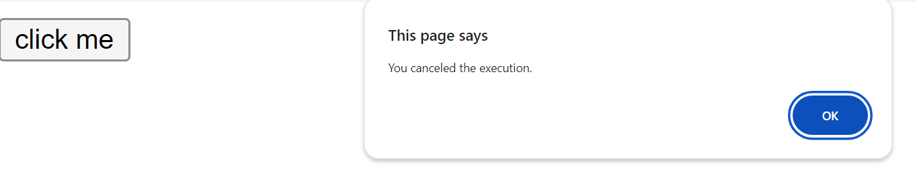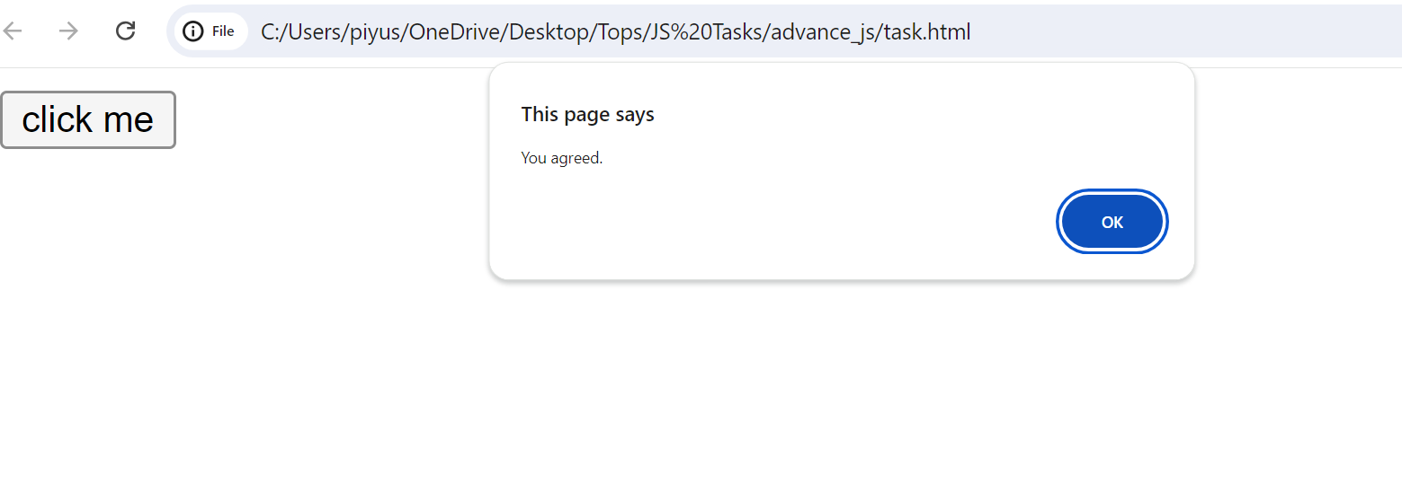

**MODULE: 2 (Data Types and Objects)**

Write the code, one line for each action:

1. Create an empty object user:

=>let user = {};

b) Add the property name with the value John.

=>let user = {};

    user.name = 'John';

c)Add the property surname with the value Smith.

=>let user = {};

    user.name = 'John';

user. Surname = 'Smith';

d) Change the value of the name to Pete

=>let user = {};

    user.name = 'Pete';

e) Remove the property name from the object.

=>let user = {};

    user.name = 'John';

    deleteuser.name;

Q.2 Is array copied? let fruits = ["Apples", "Pear", "Orange"]; // push a new value into the "copy" let shopping Cart = fruits; shoppingCart.push("Banana"); // what's in fruits? alert (fruits. Length); //?

Ans2

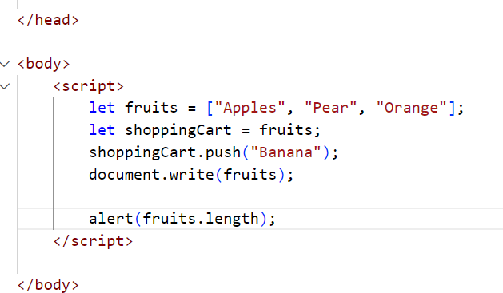

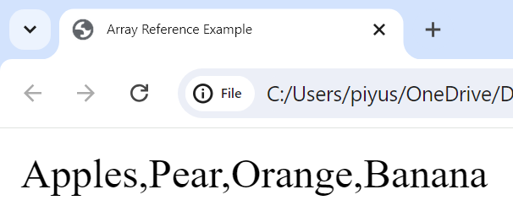

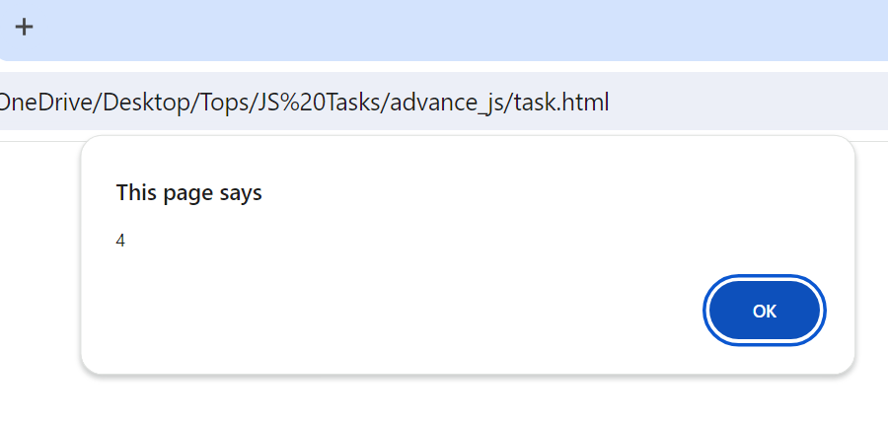

Q-3Map to names let john = { name: "John", age: 25 }; let pete = { name: "Pete", age: 30 }; let mary = { name: "Mary", age: 28 }; let users = [ john, pete, mary ]; let names = /* ... your code */ alert( names ); // John, Pete, Mary.

Ans-3

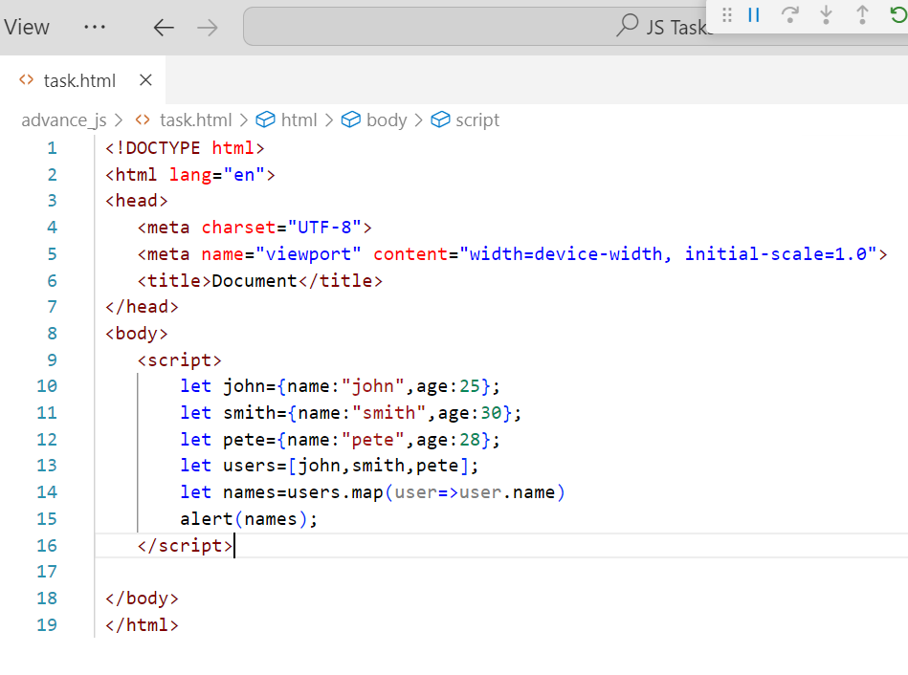

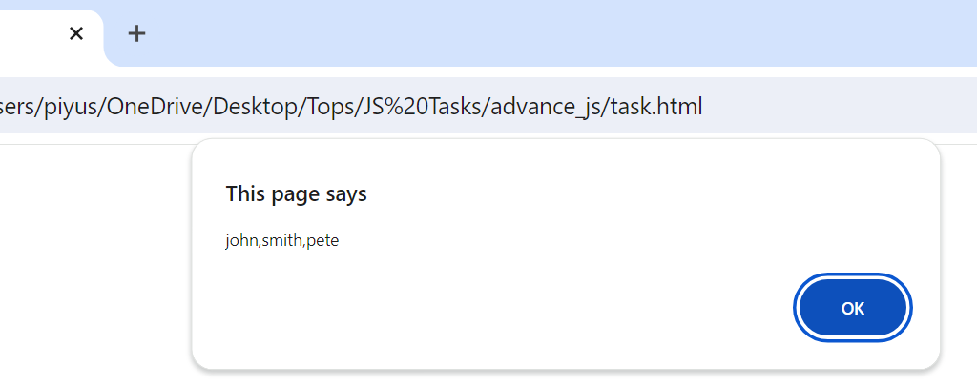

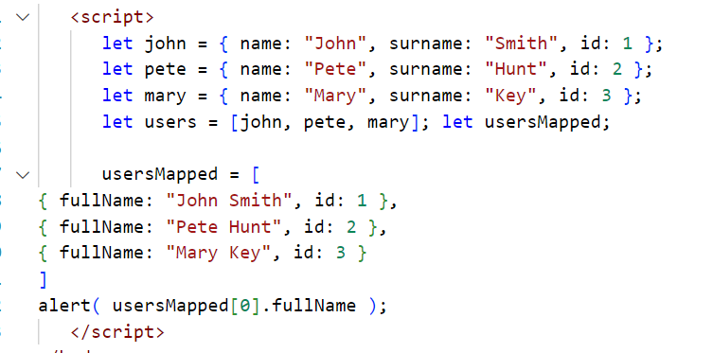

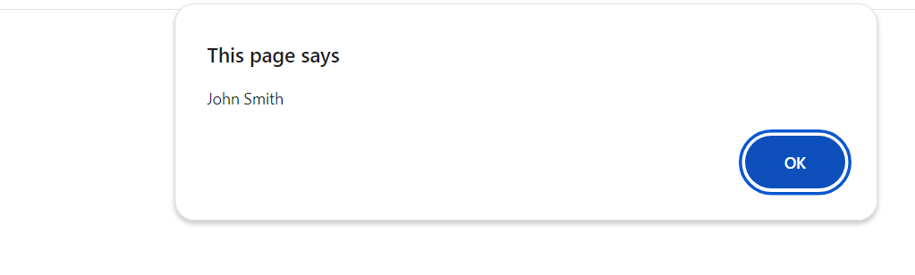

MODULE: 3 (Document, Event and Controls)

Q-1 Create a program to hide/show the password?

A-1

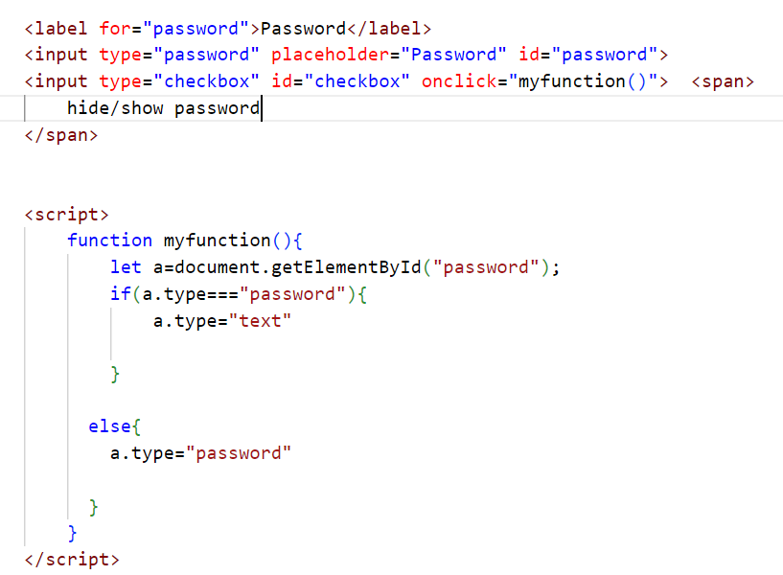

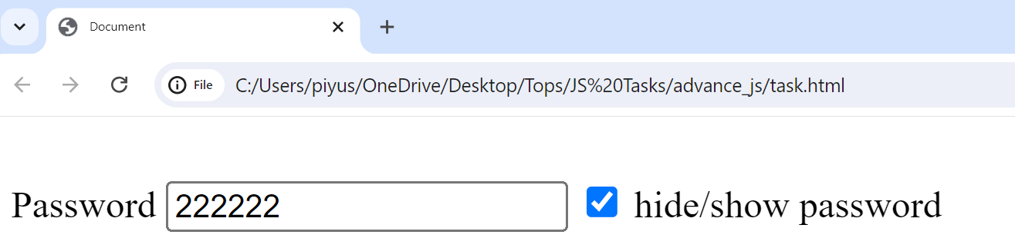

Q-2 Create a program that will select all the classes and loop over and whenever i click the button the alert should show.

Ans-

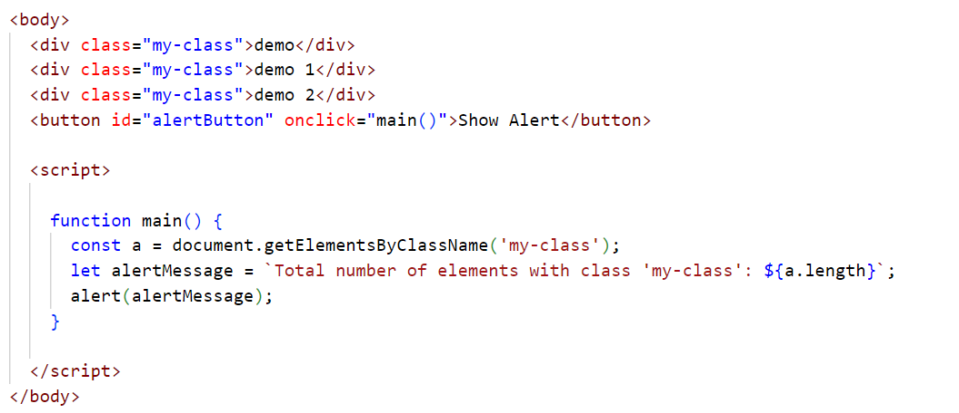

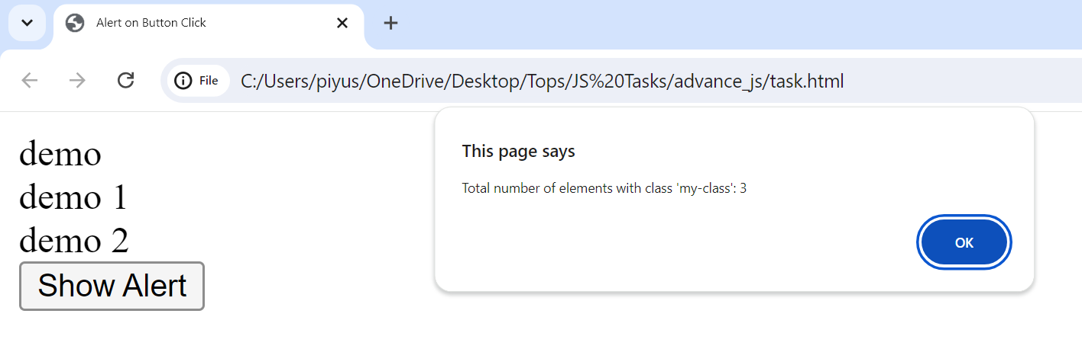

Q-3 Create a responsive header using proper JavaScript.

<file:///C:/Users/hites/Desktop/js%20images/javascript/assigment2.html>

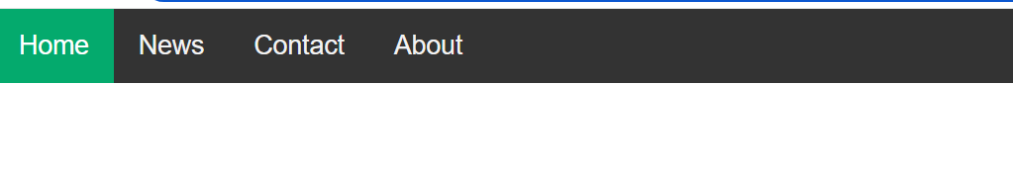

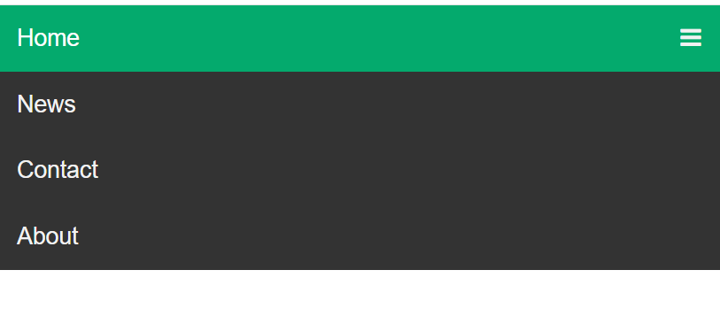

Ans-

Q-4 Create a form and validate using JavaScript

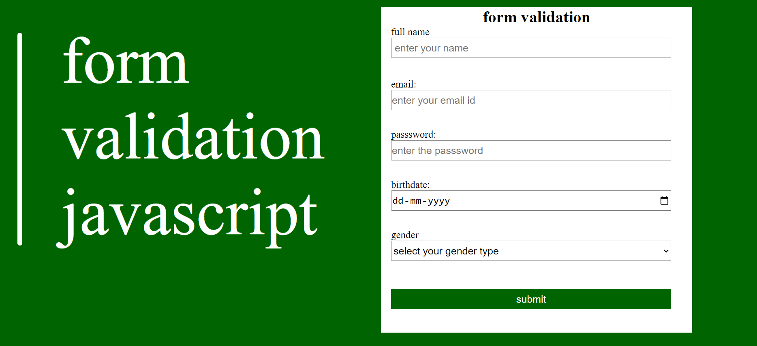

Q-5 Create a modal box using css and Js with three buttons

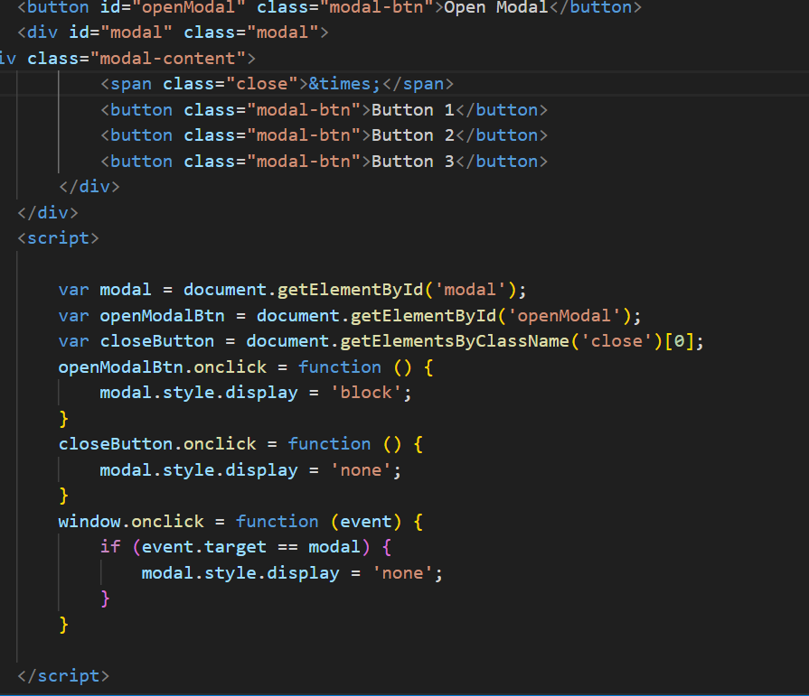

Q-6 Use external js library to show slider

<file:///C:/Users/hites/Desktop/js%20images/javascript/slider.html>







Q-7 Prevent the browser when i click the form submit button

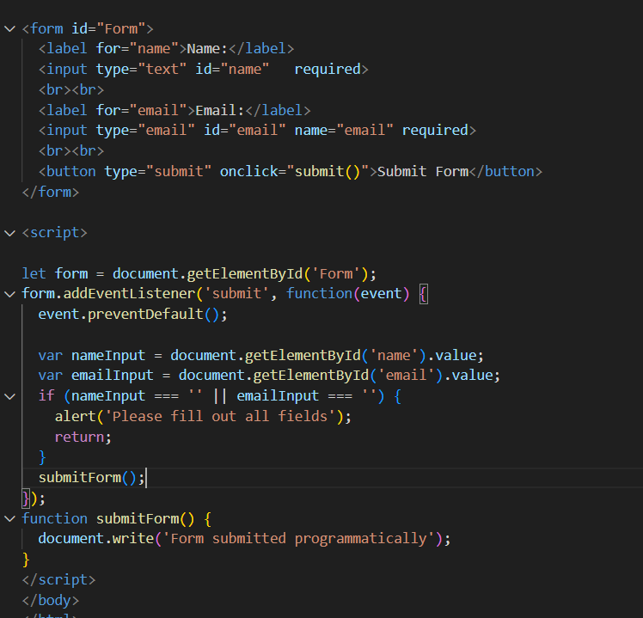

MODULE: 4 (New Request)

Q-1 What is JSON

=>json is a javscript object notation

=>json is alight-weight data

=>json is a interchange formate so easy for human read and write

=>json is a transfer data between a server and web application

=>json is build in two structures

1)object

2) arrays

Example of json

"firstName":"John",

"lastName":"Doe",

"age":30,

Q-2 what is promises

=> Promises are a fundamental concept in JavaScript used for handling asynchronous operations.

=>They provide a more structured way to deal with asynchronous code compared to traditional callback functions.

Characteristics of Promises:

1. Asynchronous Operations

**2)state**

3)Chaining

Q-3 Write a program of promises and handle that promises also

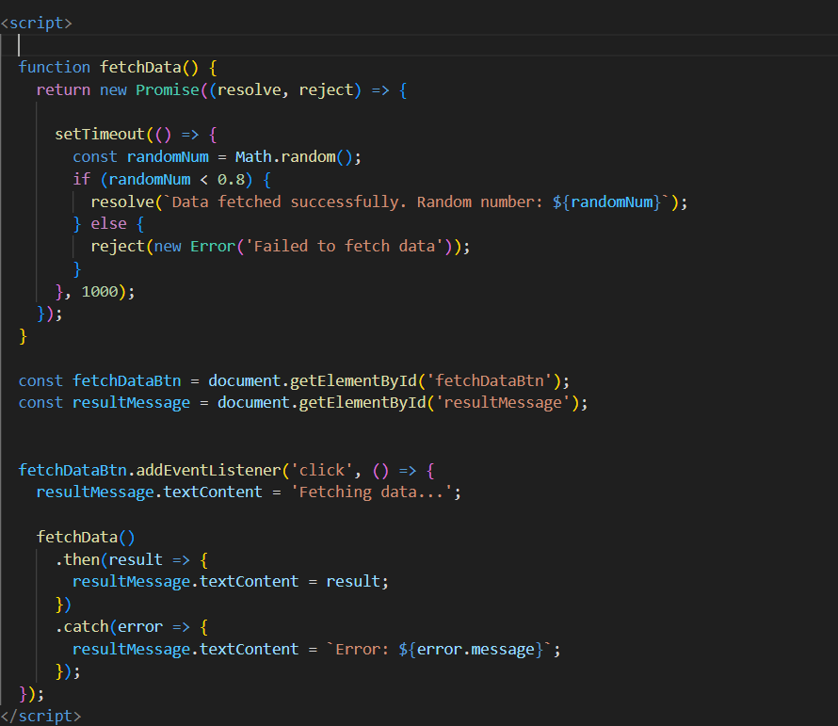



Q-4 Use fetch method for calling an api https://fakestoreapi.com/products

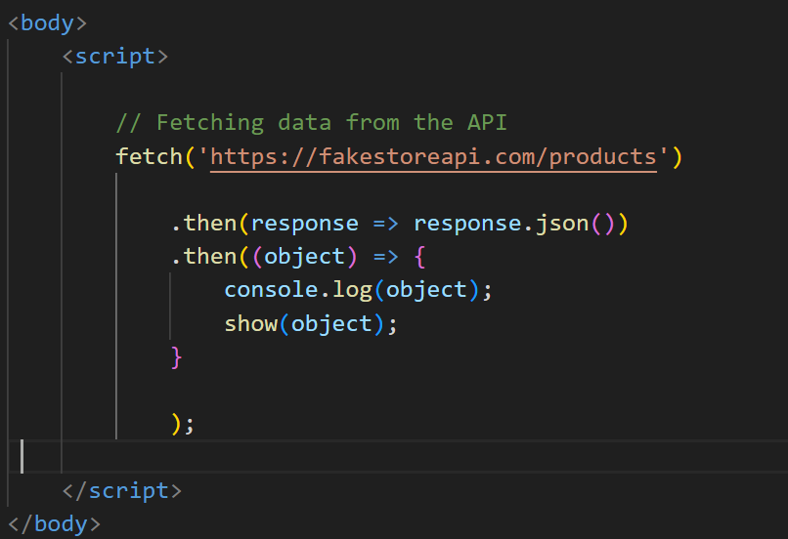

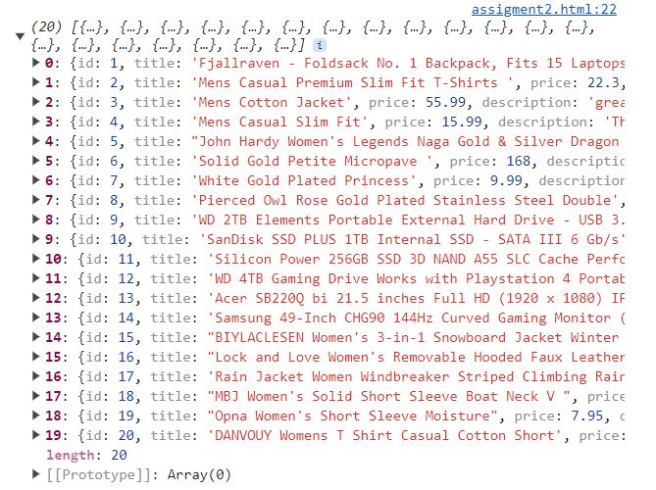

Q-5 Display all the product from the api in your HTML page

